This chart shows the organization of getting to the program.

Sections are accessed through sessions and javaScripts.

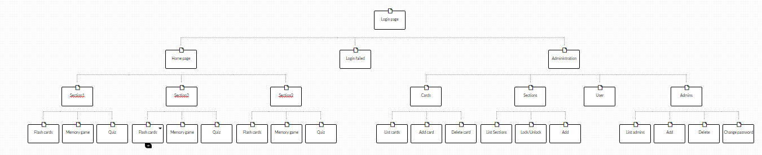

|  |  |  |
| --- | --- | --- |
| Login page | Description | Processed With Files |
| Index.html | Home Page for students and administrator | bootstrap/css/bootstrap.css  css/indexStyle.css  user_login.php |
| user_login.php | Processes form sign-in located in index.html | require session.php  db.php  location:main.php |
| session.php | Opens a session for user sign-in | location:index.html |
| db.php | Database name and access information |  |

|  |  |  |
| --- | --- | --- |
| Home page | Description | Processed With Files |
| main.php | Shows menu items  Section 1, Section 2, Section 3, each with  Flash Cards, Memory Game, Quiz | require session.php  bootstrap/css/bootstram.min.css  jquery-ui.css  css/mainStyle.css  logout.php  require db.php  flashcard.php  memoryGame.php  quiz.php  admin/index.php  script/mainScript.js |
| logout.php | closes the user’s session and returns to the login page | Index.html |
| flashcard.php | Shows aviation photos and presents audio | require session.php  css/flashcard.css  <http://code.jquery.com/jquery.js>  sectionGrabber.php  admin/index.php |
| sectionGrabber.php |  | require session.php  db.php |
| memoryGame.php | Shows 9 boxes, 8 have question marks, the center box has title “Section 1”  This is a concentration / memory game to match aviation terms | require session.php  css/memoryStyle.css  main.php |
| quiz.php | Sets up the quiz and connects to the database  Shows a picture and multiple choice answers | require session.php  require db.php  css/quizStyle.css  script/cardManager.js  script/quiz2Script.js  main.php |
| quiz2Script.js | Processes three questions and shows them in a card format | quizResult.php |
| quizResult.php | Show the total questions right, and number of questions | css/matchResultStyle.css |

|  |  |  |
| --- | --- | --- |
| javaScript | Description – Processes related section | Processed With Files |
| sectionone.js | Shows card, word, audio, image, description |  |
| sectiontwo.js | Shows card, word, audio, image, description |  |
| sectionthree.js | Shows card, word, audio, image, description |  |
|  |  |  |

|  |  |  |
| --- | --- | --- |
| Administration | Description | Processed With Files |
| admin/index.php | Home page for the Administrator’s site | require session_admin.php  bootstrap/css/bootstrap.min.css  admin.php |
| admin.php |  | require session_admin.php  db.php  bootstrap/css/bootstrap.min.css  <http://cdn.datatables.net/1.10.4/css/jquery.dataTables.css> |
|  |  |  |
|  |  |  |
|  |  |  |
|  |  |  |
|  |  |  |
|  |  |  |